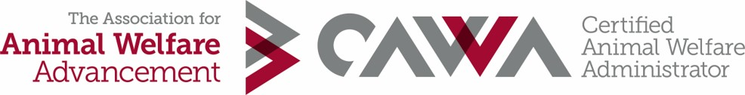
REFERENCE for CAWA Application
_______________________________ has requested that you serve as an employment reference to verify eligibility for the Certified Animal Welfare Administrator (CAWA) credential. The CAWA certification program is designed to validate the unique knowledge and skills required of leaders in animal welfare. Please assist us in verifying the professional experience of this applicant, preferably saved as a PDF file. The applicant will submit a copy of this reference to The Association for Animal Welfare Advancement.

Applicant Name:
Applicant email:
Applicant Job Title:
Organization:
Applicant Job Start Date:
Applicant Job End Date or note if currently in position:
Date of this Reference:
Reference Name:
Reference Title:
Reference Daytime Phone:
Reference Email:
Reference Organization:
Organization Address:

Title you had during the applicant’s above employment:
Describe your supervisory/reporting relationship to the applicant (direct supervisor, CEO, board member, HR Manager, etc):
Did the applicant manage paid staff at this position? YES/NO
Did the applicant manage volunteers at this position? YES/NO
Organization type = Animal sheltering, spay/neuter, and/or field services organization: YES/NO
Organization type = Not-for-profit or government organization: YES/NO
Reference signature:

Thank you for your assistance. If you have questions, please contact The Association for Animal Welfare Advancement Certification Team at certification@theaawa.org.
PLEASE SAVE THIS FILE AS A PDF AND RETURN TO APPLICANT

